## 



SRI LANKA INSTITUTE OF INFORMATION TECHNOLOGY

[Enterprise Standards and Best Practices for IT Infrastructure](http://courseweb.sliit.lk/course/view.php?id=137)

**4thYear 2nd Semester 2016**

**Assignment**

**Baremetal Virtual Machine Installation**

Lab 04 – Installation of ESXi 5 (VMware Hypervisor Installation)

Lab 05 – Creating a Virtual Machine on the Hypervisor

## Dewindi U.K.A

## IT13023942

## WEEKEND IT

Lab 04 – Installation of ESXi 5 (VMware Hypervisor Installation)

### Step1

### Click on Create new virtual machine.

.

### 1.PNGStep2

### Click “Next” button.

### 2.PNG

### Step3

### Select ‘Installer disk image file (iso)’ from next window. Browse for the ESXi 5 iso and click ‘Next’.

### 3.PNG

### Step4

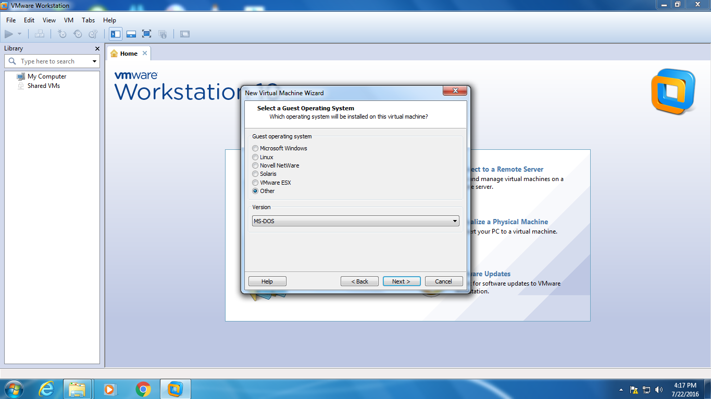

### 5.PNGStep5

### Give a name for the virtual machine. Browse for a location to save and click ‘Next’.

### Step6

### 6.PNGSpecify the disk capacity.

### Choose ‘Store virtual disk as a single file’ and click ‘Next’.

### Step7

### Check the settings we gave previously and click ‘Finish’ button.

### 7.PNG

### Step8

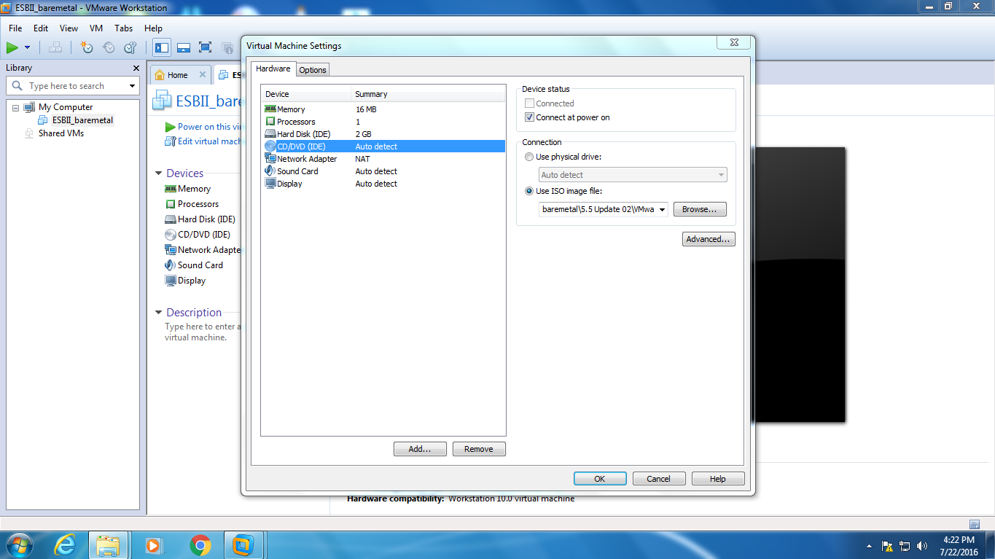

* **Step 9**

Wait few seconds for automatic boot. Then the installation will continue.

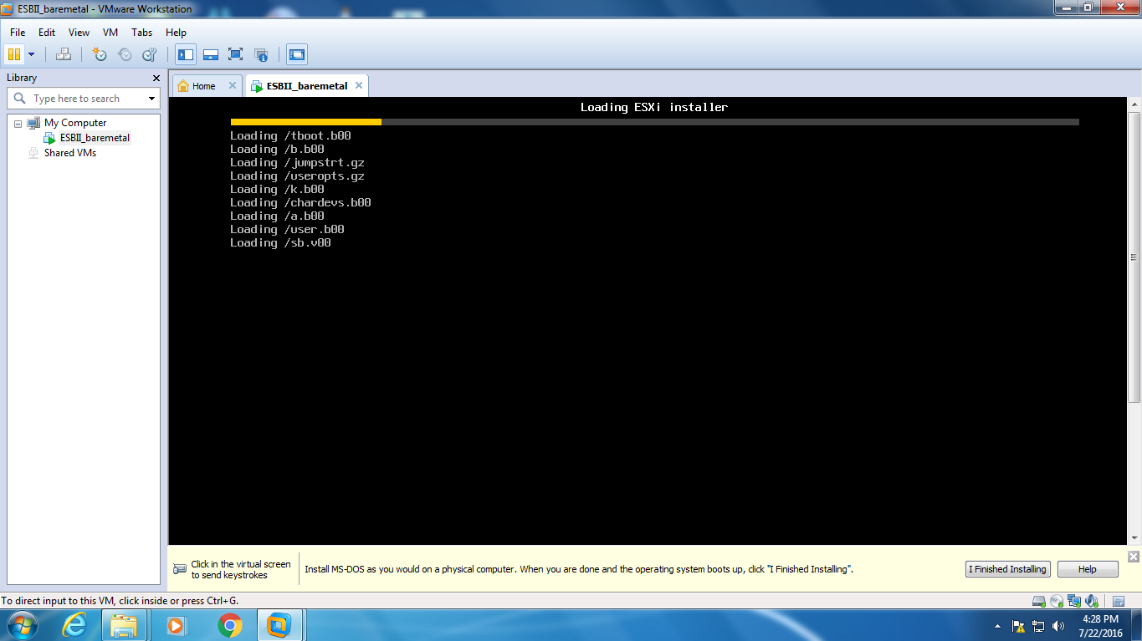

### Step10

### 10.PNG

### Step11

### 11.PNG

### Step12

### 12.PNG

### Step13

### 13.PNG

### Step14

### Press ‘Install’ button to continue installation. Click “F11” for install.

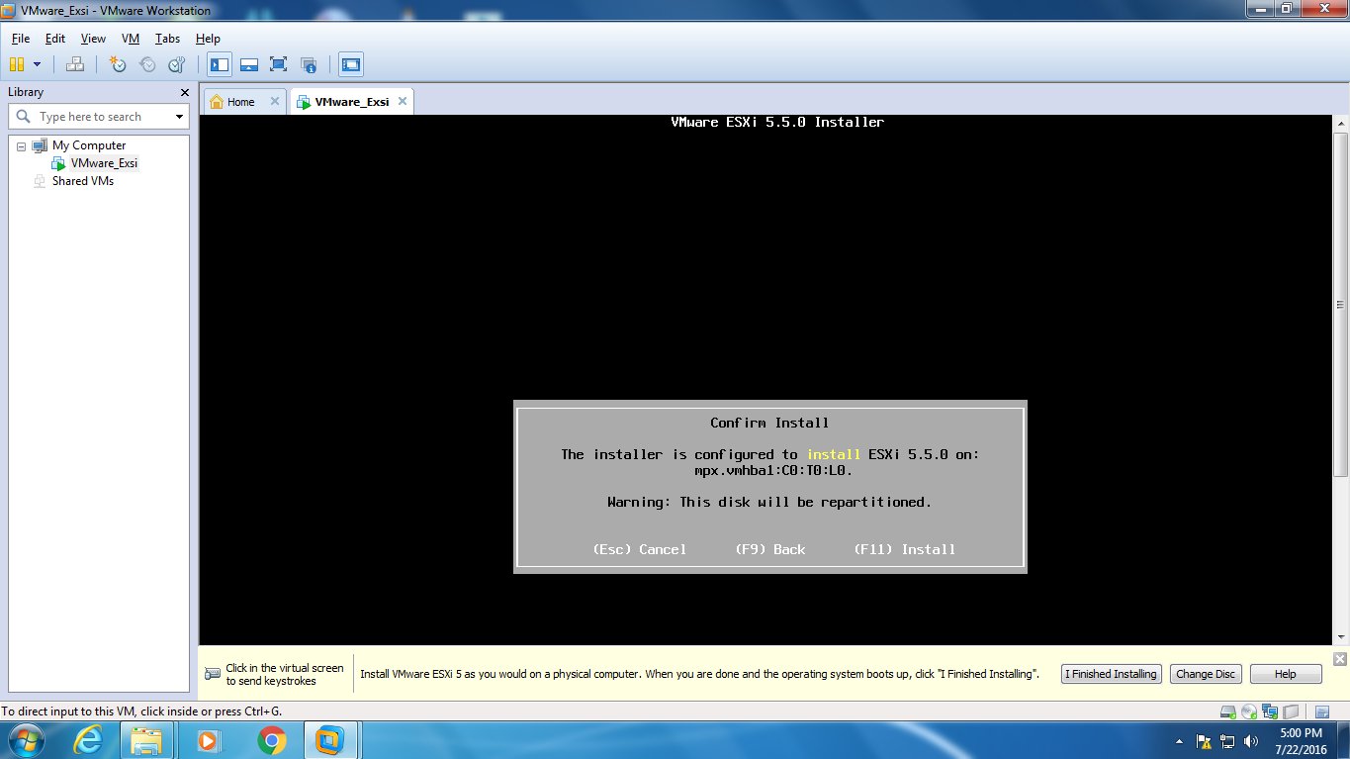

### Step15

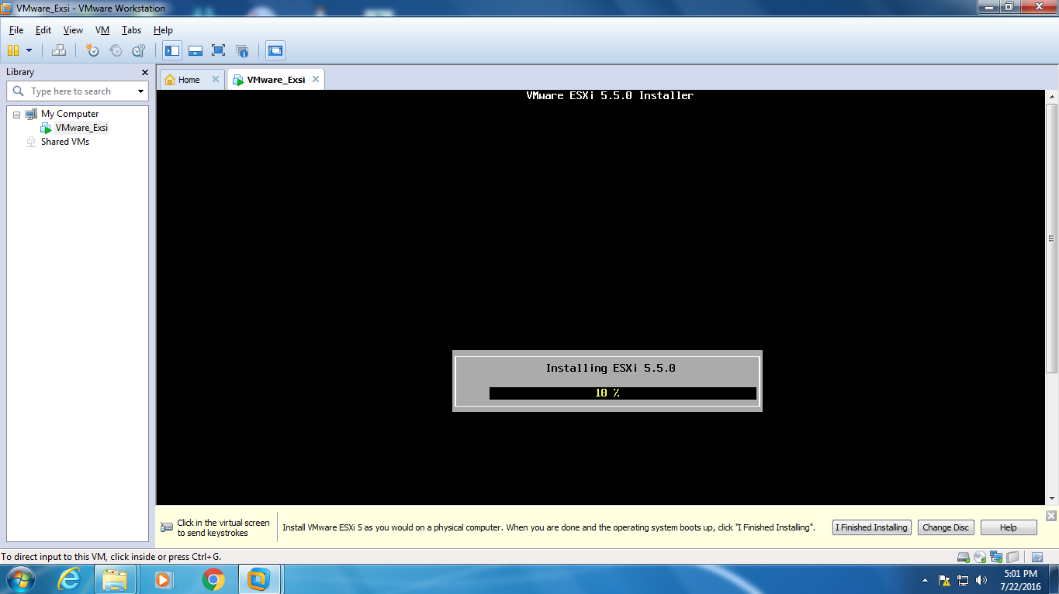

### Step16

### Press ‘Enter’ button to continue for reboot.

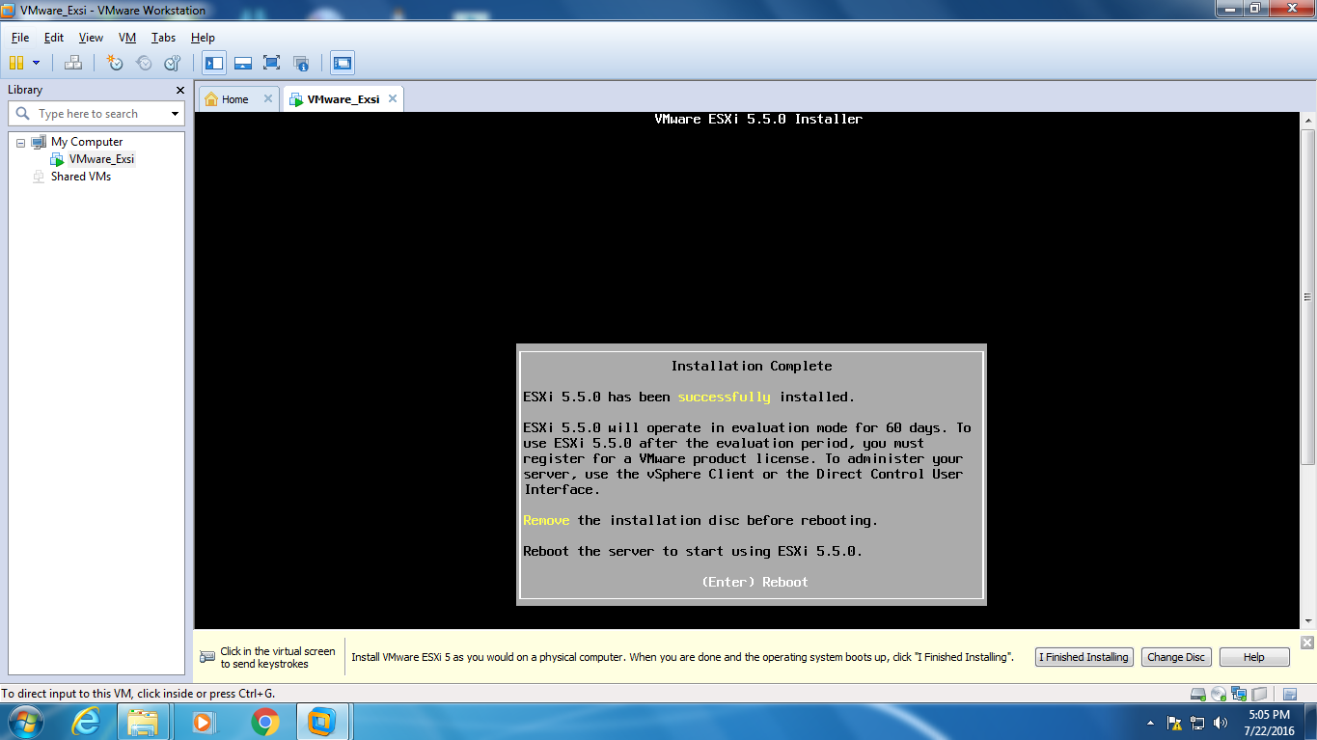

### Step17

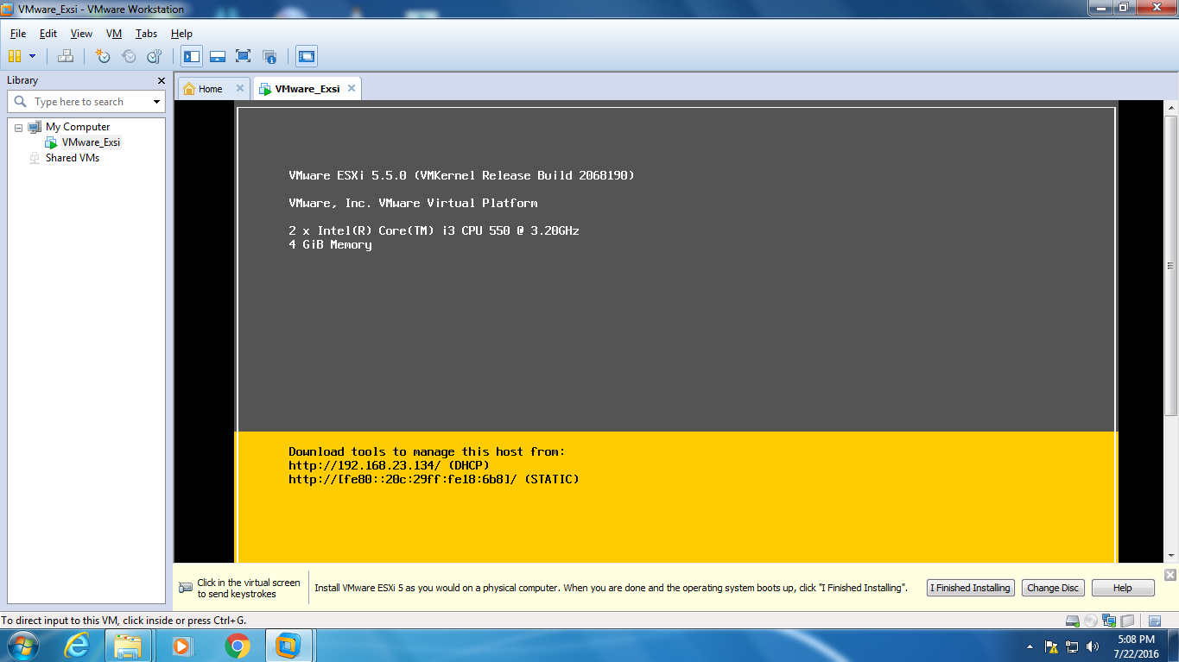

### Step18

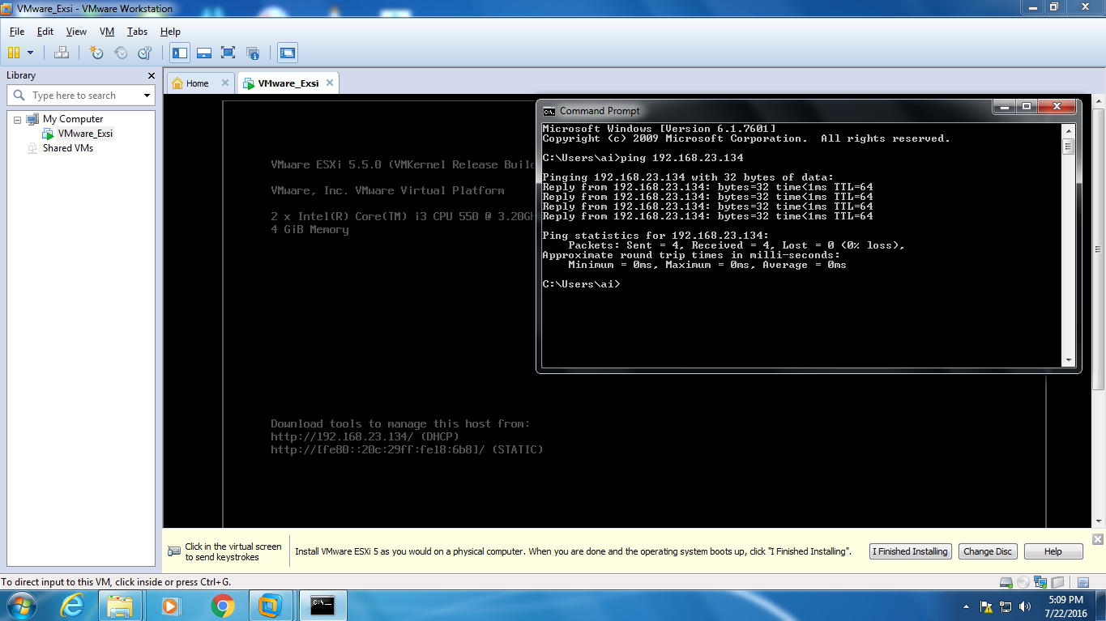

Lab 05 – Creating a Virtual Machine on the Hypervisor

### Step01

### Power on ESXi 5 from VMware Workstation.

### Install VMware vSphere Client software. Provide the IP address of ESXi 5 host. Login to the system by using username and password.

### 13.PNG

### Step02

### 15.PNGIgnore the SSL certificate security warning.

### 16.PNGStep03

### Step04

### Go to the ‘Summary’ tab

### 17.PNG

### Step05

Right click on ‘datastore1’ from ‘Storage’ category and choose ‘Browse Data store...’

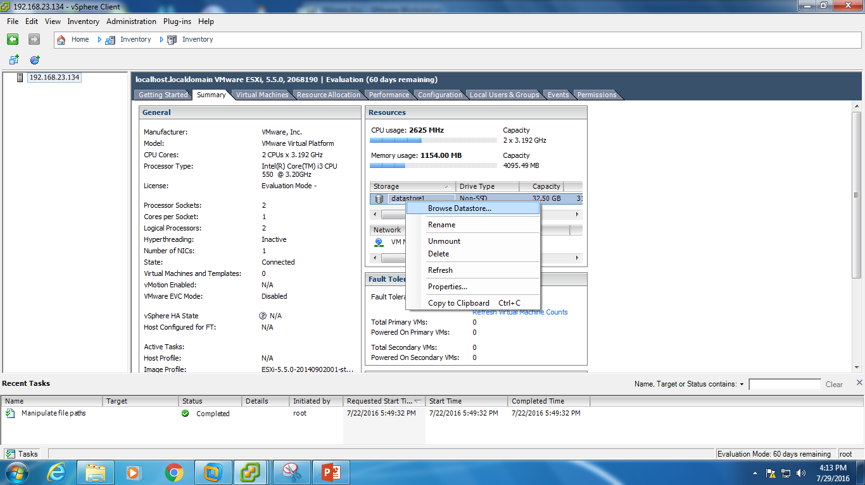

### Step06

### 19.PNGChoose ‘Upload File’ from ‘Upload files to this data store’ icon.

### Step07

### Right click on the host and choose ‘New Virtual Machine’.

### 1.1.png

### Step08

### Select ‘Typical’ under ‘Configuration’ and click ‘Next’.

### 1.PNG

### 2.PNGStep09

### Give a name for the virtual machine and click ‘Next’.

### Step10

### Click ‘Next’ button on ‘Storage’ section

### 3.PNG

### Step11

### Select ‘Linux’ under ‘Guest Operating System’. Select ‘Other Linux (64-bit)’ and click ‘Next’ button.

### 5.PNG4.PNGStep14

### Click ‘Next’ on ‘Network’ section.

### Step15

### Select ‘Thin Provision’ on ‘Create a Disk’ section and click ‘Next’.

### 6.PNGStep16

### 7.PNGClick ‘Finish’ button.

### Step17

### Right click on the created virtual machine and choose ‘Edit Settings’. Change the memory size to 2048 MB. Select ‘CD/DVD drive 1’ and choose ‘Datastore ISO File’. Browse for the ISO file from the datastore.

### Select ‘Connect at power on’ from ‘Device Status’ and click ‘OK’.

### 8.PNG

### Step18

### Select “Power on the virtual machine”.

### 9.PNG

### Step19

### Go to the ‘Console’ tab and choose ‘Live (amd64)’. Press ‘Enter’ to start installing ‘Kali’ on the created virtual machine.

### 2.PNG

### Step20

### 3.1.PNG

### 3.2.PNGStep21

### Step22

